Curriculum Vitae

Full name: Dinh Thi Sen

Email: sendt@ntu.edu.vn
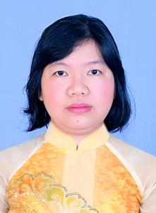

Department of Social Sciences & Humanities
Faculty of Social Sciences and Humanities
Nha Trang University
02 Nguyen Dinh Chieu St., Nha Trang City, Vietnam

EDUCATION
HCMC University of Education, Ho Chi Minh City, Vietnam
MSc. in Psychology, 2014

University of Social Sciences and Humanities, Hanoi City, Vietnam
Bachelor in Psychology, 2001

RESEARCH INTERESTS
- Behavior psychology
- Stages of Development of Psychology of People
RESEARCH EXPERIENCE

TEACHING RESPONSIBILITY

Undergraduate:

General psychology

Communication skills

Graduate:

PUBLICATIONS and PRESENTATIONS

Books:
- Tran Thi Viet Hoai, Le Thi Thanh Nga, Dinh Thi Sen, Communication Skills, Literature Publisher, Hanoi, Vietnam, 2018, ISBN: 978-604-963-306-5

Journals:

Presentations:

